Cleaning and Maintenance Information

Accessories

Stairtile
Data Sheet: (sheet 1 of 2) July 2012

This leaflet has been compiled to help the user obtain optimum performance and satisfaction from their selected product:

Preventative Maintenance Programme

A regular scheduled maintenance programme should be employed to prevent the build up of dirt and grease, which will reduce the slip-resistant properties of Stairtile and detract from the overall appearance of the product.

NB. Under no circumstances should any cleaners containing hydrocarbons, bleach, pine oil or citrus based agents be used to clean Stairtile.
Steam cleaners, floor sealants, polishes or any coatings should not under any circumstances be used on Stairtile.

External Applications
Twice Weekly or as Required

To remove everyday dirt pressure wash Stairtile using a 200 – 250 bar pressure washer with a traffic film remover. Stubborn marks can be removed by scrubbing Stairtile with a stiff bristled brush and heavy duty alkaline cleaner.

On completion the staircase should not be used until completely dry.

Internal Applications
Twice Weekly or as Required

Brush down the channel using a soft bristled brush. With clean, warm water, containing the correct dilution of cleaning solution apply a small amount to a well rung out damp mop or a Vileda Padmaster/3M Doodlebug and gently clean the surface of the insert in a left to right motion. During the clean, the water must be changed on a regular basis. Once Stairtile has been cleaned thoroughly rinse with fresh, clean water, making sure as much water is removed as possible.

On completion the staircase should not be used until completely dry.
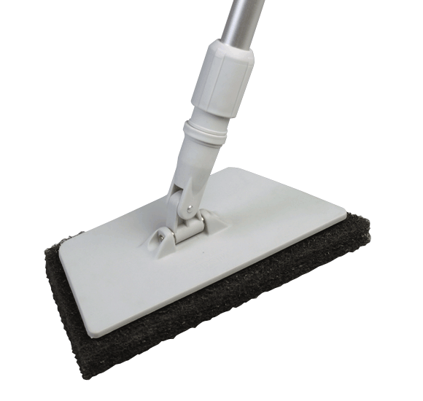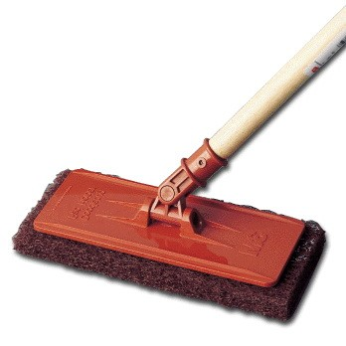

Stubborn marks can be removed by scrubbing Stairtile with a stiff bristled brush and heavy duty alkaline cleaner.

On completion the staircase should not be used until completely dry.


Gradus Accessories, Park Green, Macclesfield, Cheshire SK11 7LZ England UK Tel: 01625 428922 Fax: 01625 433949
www.gradusworld.com

Stairtile

Data Sheet: (sheet 2 of 2) July 2012
Cleaning and Maintenance Information
Gradus Accessories, Park Green, Macclesfield, Cheshire SK11 7LZ England UK Tel: 01625 428922 Fax: 01625 433949
www.gradusworld.com

Accessories
Recommended Cleaning Products for Stairtile

Gradus has worked with Selden Research to undertake extensive testing on all Gradus stair edgings and slip-resistant flooring materials. As a result, a range of cleaning products has been recommended for use with Gradus stair edgings and slip-resistant flooring materials in a variety of environments.

The cleaning products listed below are suitable for Stairtile.

For further information about these cleaning products, including environment suitability, instructions for use and COSHH data sheets, please contact:
Selden Research Limited, Staden Business Park, Staden Lane, Buxton, Derbyshire, SK17 9RZ.
Tel: 01298 26226
Email: gradus@selden.co.uk
Web: www.selden.co.uk

Product Description | Name of Cleaner | Code | Vinyl Floor Safe
Neutral Cleaners | Neutral Scrubber Drier Detergent | F176 | Yes
Neutral Cleaners | Sabre | C054 | Yes
General Purpose Cleaners | Multi Purpose Cleaner | F010 | Yes
General Purpose Bactericidal Cleaners | Selgiene | C020 | Yes
General Purpose Bactericidal Cleaners | Selgiene Ultra | C066 | Yes
Heavy Duty Alkaline Cleaners | H.D. Degreaser | F052 | Yes
Heavy Duty Alkaline Cleaners | Selclen S | F014 | Yes

